Lead Generation Process
User Guide – August 25, 2011

Page 1: Lead Generation Process Flow
Pages 2-4: Email / Phone / Other Lead
Page 5: “Contact Us” Lead
Page 6: DLPE/Non DLPE Courses Lead

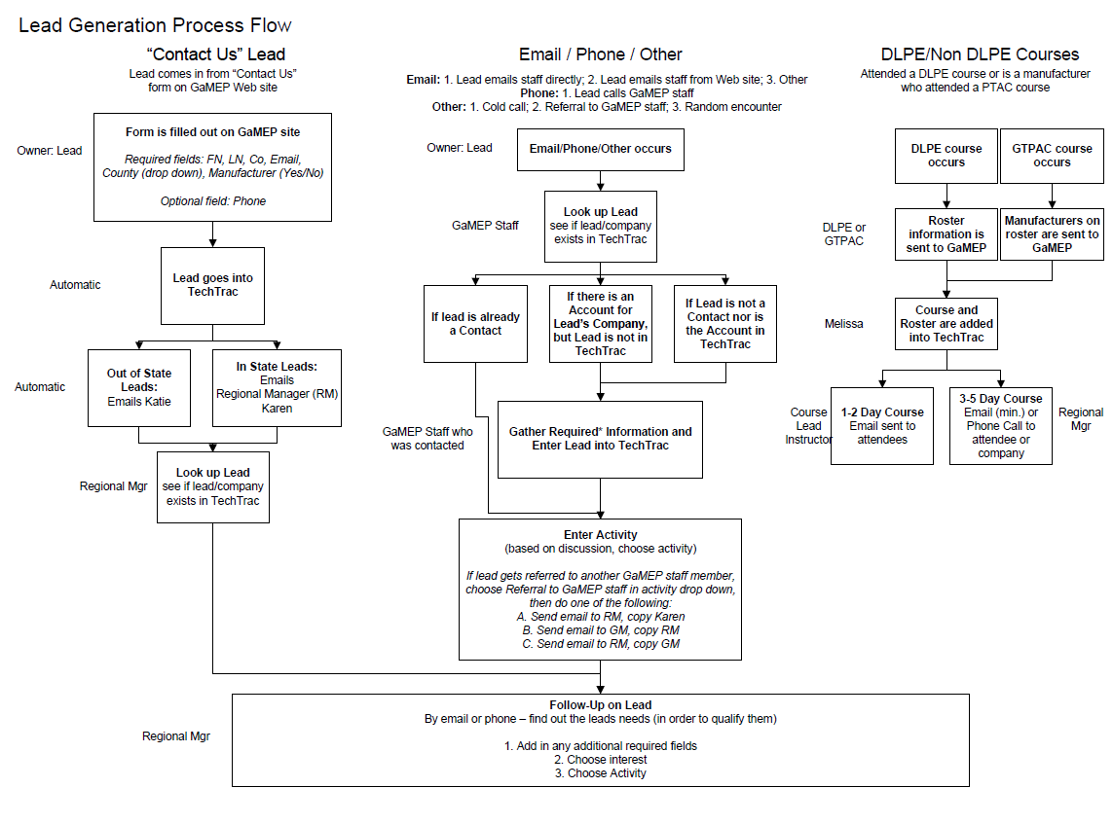

Email / Phone / Other (Manual)
- Email / Phone / Other occurs
- Check to see if Lead is already in system as a Lead or Contact or if the Lead’s Account is already in system
  - See below on how to check system:
Checking Leads, Contacts, and Accounts can all be done under the Lead Tab (click Add a Lead to be able to search all in one place).
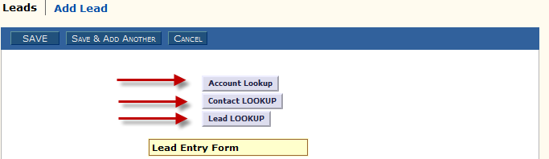
THEN
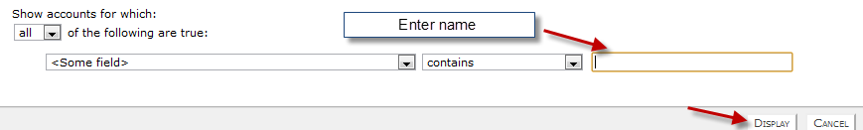
(Repeat this process, if necessary, under all three buttons – Account, Contact, and Lead). Leads, Contacts, and Accounts can also be looked up by going under the individual tab and selecting “Find Leads”, “Find Contacts”, or “Find Accounts”.
IF LEAD OR ACCOUNT IS IN SYSTEM, RESULTS WILL DISPLAY
- If Lead is already a Lead or Contact in the TechTrac System, do not make a duplicate entry. Instead proceed to step 5e.
- If there is an account for the Lead’s Company, but Lead is not in TechTrac, follow steps 5a through 5f.
  - Then click “Convert Lead to Contact” button (below Activities table) and tie them to their company’s Account

- If Lead is not a Contact nor is the Account in TechTrac, follow the below steps:
  - Click “Leads”
  - Select “Add a New Lead”
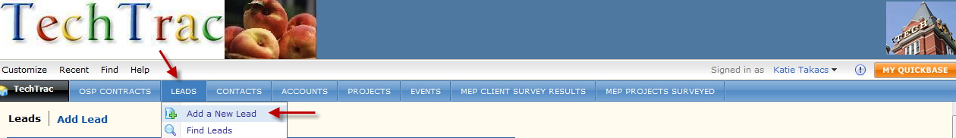

  - Enter required information and any additional information necessary, such as area of interest and comments.
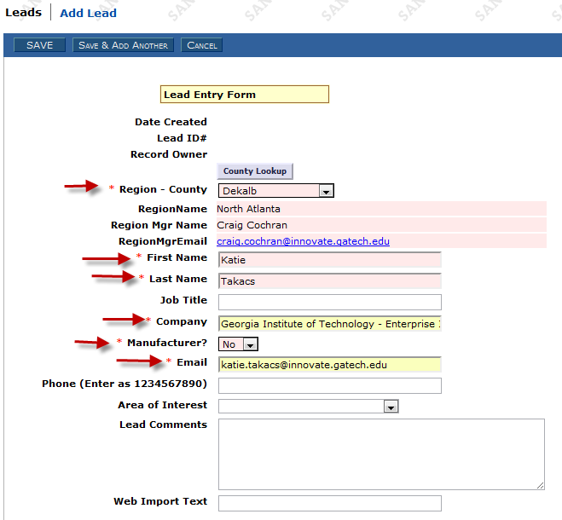
    - RegionName, Region Mgr Name, and RegionMgrEmail automatically populate based on county chosen
    - New feature: County lookup link
  - Click “Save”
  - Add activities
    - Continue to add future activities for the Lead
    - See below on how to add an activity to a Lead

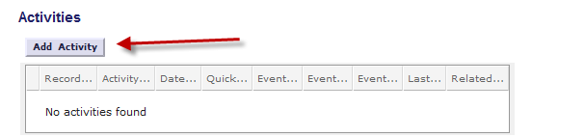
  - Activity menu
    - Choose Activity Type
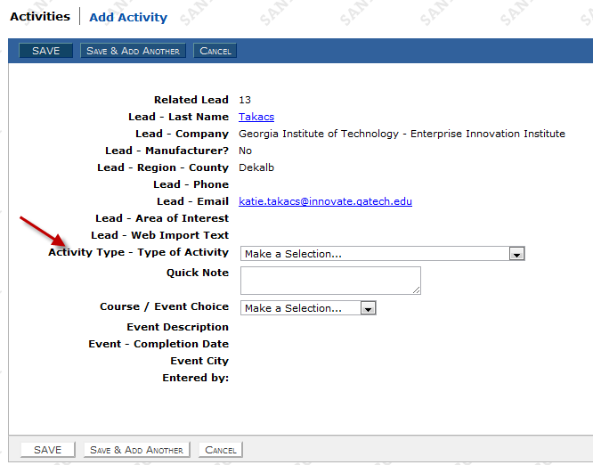
    - Drop down menu selection under Activity Type
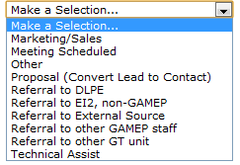
  - View of Activity fields (once activity is chosen from drop down menu)
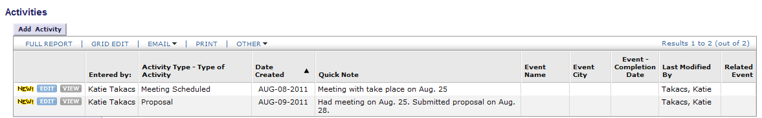
Contact Us Lead (Automatic)
- Lead comes in from Contact Us form on GaMEP Web site
  - Lead gets automatically populated into TechTrac
  - An email notification gets automatically generated and sent to the Regional Manager, based on the county the Lead is in
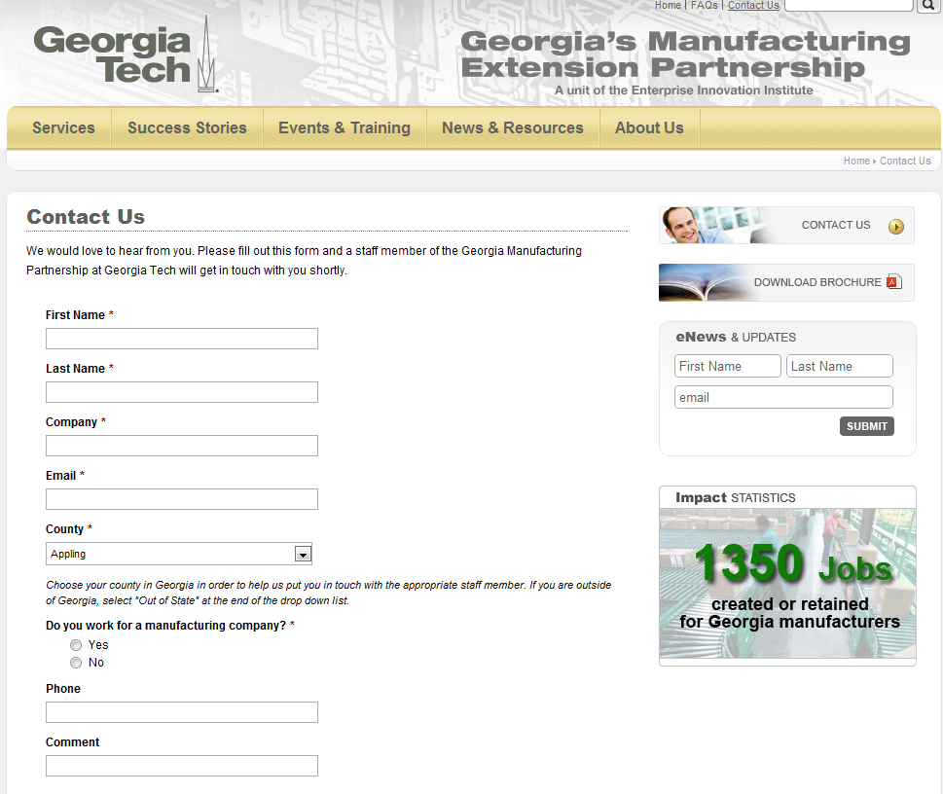
- Check to see if Lead is already in system (as a Lead or Contact) or if Account is already in system (refer to Step 2 on Email / Phone / Other)
- Follow-up on Lead
  - Edit current fields (if needed) and add information additional required fields, interest, and activity to lead record (refer to Step 5e on Email / Phone / Other)
    - Continue to add future activities for the Lead
    - Comments can be added to activities (see Step 5e on Email / Phone / Other)

DLPE / Non DLPE Course
- DLPE or Non DLPE course occurs
- Roster (DLPE course) or Manufacturers on roster (non DLPE course) is sent to GaMEP
  - Rosters sent to Melissa Teske from DLPE or Non DLPE course host
- Course and roster are added to TechTrac (under Events)
  - Melissa Teske enters information into TechTrac
- Follow-up with course attendees
  - 1-2 day course
    - Email sent by course lead instructor to attendees (1-2 weeks after course commences). Example of email:

%%firstname%%,

Thank you for attending %%coursename%% on %%coursedates%%. If you have any follow-up questions regarding the material, please let me know.

In addition, we offer both onsite assistance and training in areas such as Strategic Business Development, Lean / Process Improvement, Quality Management, Sustainability, Energy Management, and Product Development. For more information on how these services can help your company, please visit and bookmark our Web site at www.gamep.org or contact me.

Thank you
%%LeadInstructorName%%

  - 3-5 day course
    - Melissa sends Regional Managers attendee information from their region
    - Email sent (or phone call made) by regional managers to attendees in their region (1-2 weeks after course commences). Example of email:

%%firstname%%,

I hope this email finds you doing well. My name is %%firstname%% %%lastname%% and I am the %%regionname%% Regional Manager for the Georgia Manufacturing Extension Partnership at Georgia Tech.

I wanted to thank you for attending %%coursename%% on %%coursedates%% and also introduce myself as your regional contact.

In addition to the course you took at Georgia Tech, we offer both onsite assistance and training in areas such as Strategic Business Development, Lean / Process Improvement, Quality Management, Sustainability, Energy Management, and Product Development. For more information on how these services can help your company, please visit and bookmark our Web site at www.gamep.org or contact me.
Thank you
%%RegionalManagerName%%

